HTML5 Audio

# Documentation

* HTML Audio Element (HTML): <https://developer.mozilla.org/en-US/docs/Web/HTML/Element/audio>
* HTMLAudioElement interface (JavaScript - HTML Media API): <https://developer.mozilla.org/en-US/docs/Web/API/HTMLVideoElement>
* Web Audio API: <https://developer.mozilla.org/en-US/docs/Web/API/Web_Audio_API>
* Web RTC API: <https://developer.mozilla.org/en-US/docs/Web/API/MediaDevices/getUserMedia>

# Samples

* <https://scopanum.cloudapp.net/ase/>
* Sound visualization using HTM5 Canvas: <http://nipe-systems.de/webapps/html5-web-audio/>

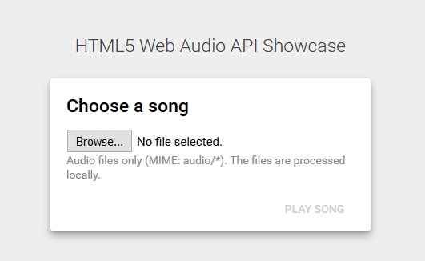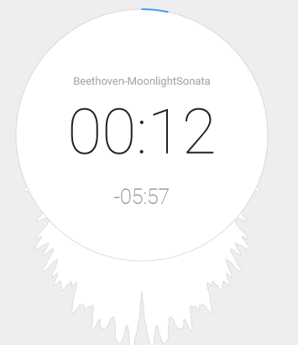

* Creating visualizations: <https://developer.mozilla.org/en-US/docs/Web/API/Web_Audio_API/Visualizations_with_Web_Audio_API>
* Record and save as MP3: <http://audior.ec/blog/recording-mp3-using-only-html5-and-javascript-recordmp3-js/> , <https://www.html5rocks.com/en/tutorials/getusermedia/intro/>